Text Mining Project Report
Amir Adilkhan 476913
Kostiantyn Okhrimenko 473494
Norbert Jaworski 474891
Semantic Topic Modeling and Ontology-Oriented Text Mining of a Large Heterogeneous Document Corpus (Published Epstein Files)
https://github.com/Endote/ontology

Introduction
Nowadays, the importance of text mining techniques allowing to extract useful information from bunches of unstructured textual data cannot be underestimated. On the first glance, some documents can be considered the ones that do not contain any useful information. In fact, most of the useful information is stored in form of semi-structured or unstructured documents (2020). In this project, we utilised text mining techniques to retrieve as much useful information from the Epstein files as possible.

Data Description
Data used in this project came from Kaggle https://www.kaggle.com/datasets/jazivxt/the-epstein-files
The full dataset consists of over 26 thousand files, of which approximately 3000 are text documents, contained in .txt, .docx and .pdf files and nearly 23000 image-based files including not only text documents, but also pictures, schematics, diagrams and visualizations. Image based files and scanned documents were excluded in order to focus on methodology.
The resulting text corpus is highly heterogeneous, exhibiting substantial variation in document length and formatting. Many documents contain extensive boilerplate sections, headers, metadata blocks, and repeated template fragments. This heterogeneity renders naive topic modelling approaches ineffective without extensive preprocessing and structural normalization.

Goal
The goal of first part of the project is to extract robust and interpretable semantic topics, that can be suitable for downstream ontology engineering and social network analysis. The published data was a mix of different document types including significant number of artifacts. Given the scale of the document corpus, fully manual inspection is impossible. The data processing pipeline was automated in the areas of preprocessing, normalization and semantic extraction, complemented by manual supervision where required to validate assumptions and filter duplicate artifacts.
The second part of the project was aimed at conducting network analysis. This part requires Named Entity Recognition techniques allowing to retrieve names and surnames from the corpus. In this part, we did not utilise all the published files, as it would require additional data preprocessing algorithms. Instead, we mainly focused on files in text format (however, the corpus was still highly heterogenous, as it included e-mails, Excel tables and parts of internet articles). It must be stated that the relationships between the individuals extracted at this stage cannot be treated as evidence of real connections between the people. The network was built based on names co-occurrence inside a document.

Preprocessing
Semantic analysis of heterogenous document corpora requires careful preprocessing to ensure topics accurately reflect underlying semantic structure rather than artifacts of document formatting or metadata structure. Preprocessing was treated as a compulsory methodological component.
The preprocessing pipeline consisted of two stages:
- Text cleaning and normalization
- Near duplicate detection and removal

Text Cleaning and Normalization
The first stage is to transform raw document text into a normalized representation suitable for semantic analysis. The documents’ corpora contained non-semantic material, which includes boilerplate headers and footers, metadata blocks such as email and message exchange applications and formatting remnants originating from diverse information sources included in the texts.
The boilerplate content that was repeated across large number of documents was identified using rule based heuristics based on frequency analysis of similarity detection.
Normalization used included standardization of whitespace, punctuation and ASCII character harmonization. Transformations were applied uniformly across all documents to persist normalized forms of the corpora.
Filtration was applied to the resulting collection of documents to filter out documents that were not long enough to contribute effectively to topic modelling creation.

Near Duplicate Detection and Removal
The second stage is to deduplicate similar documents found in the collection, which was conducted after the initial structural . This step is done after document form clustering is already conducted, which is described in the next paragraph, and all the boilerplate is already removed so this reduces the risk of removing semantically distinct documents whose similarity arises from shared boilerplate. The SimHash algorithm was used to generate similarity preserving hashes based of document texts, allowing them to be grouped into buckets of near-duplicates, after which a single representative document was retained from every bucket.
The remaining documents are identified in a specially created manifest uniquely identifying each file, it’s path and the contents.

Structural Clustering by Document Form
A key challenge of this document corpora is that documents differ not onlt in content, but in structure as well. Applying standard topic modelling directly can prove misleading and underrepresent some less populated structures and topics.
After non-semantic noise and repetitions were significantly removed the document corpora still exhibited considerable templating and metadata repetition. Documents were clustered by document form, defined as recurring structural and stylistic patterns independent of semantic content, using the following parameters:
- n_chars – number of characters in the document
- n_lines – number of lines in the document
- n_tokens – number of tokens in the document
- blank_lines – number of blank lines
- avg_line_len – mean number of characters per line
- max_line_len – max number of characters per line
- digit_ratio – proportion of numeric characters
- upper_ratio – proportion of uppercase characters
- non_ascii_ratio – proportion of non-ASCII characters
- email_count – number of email-like strings
- phone_like_count – number of phone-number-like patterns
- date_like_count – number of date-like expressions
- money_like_count – number of currency-like expressions
- punct_ratio – proportion of punctuation characters
- colon_ratio – proportion of colon characters
- header_line_ratio – fraction of lines resembling headers or section titles
- unique_line_ratio – ratio of unique lines to total lines
- repeated_line_max_frac – maximum fraction of repeated identical lines within a document
A clustering algorithm was applied to these structural feature representations to identify recurring document forms within the corpus. The chosen clustering approach prioritized robustness to noise and flexibility, given the absence of predefined document types. The resulting clusters represented distinct document-form groups, each corresponding to a characteristic structural pattern observed in the corpus.
The clustering conducted used the following approach:
- UMAP dimensionality reduction – retains local neighborhoods and optimizes global data dimensionality
- clustering using HDBSCAN – does not require a specific number of clusters as the input, explicitly labels noise
- a second pass of clustering was applied within each of the clusters, that were sufficiently big in size, and noise produced to find more finely grained document structures using another UMAP dimensionality reduction and another HDBSCAN
This two-pass strategy produced a general structure family clustering and a refined form type within the given family. The final clustering result is 22 document-form labels including a noise label. Below is a specific document assignment, unfortunately the labels were not produced automatically.
- c0003 → 7 refined clusters
  - c0003_r0000 103
  - c0003_r0005 85
  - c0003_r0006 72
  - c0003_r0003 59
  - c0003_r0002 57
  - c0003_r0001 40
  - c0003_r0004 29
- c0004 → 5 refined clusters
  - c0004_r0000 523
  - c0004_r0003 391
  - c0004_r0002 232
  - c0004_r0004 199
  - c0004_r0001 113
- c0007 → 3 refined clusters
  - c0007_r0002 111
  - c0007_r0001 86
  - c0007_r0000 28
- c0006 → 2 refined clusters
  - c0006_r0001 310
  - c0006_r0000 22
- c0000 → 1 refined cluster
  - c0000_r0000 86
- c0001 → 1 refined cluster
  - c0001_r0000 154
- c0002 → 1 refined cluster
  - c0002_r0000 67
- c0005 → 1 refined cluster
  - c0005_r0000 71
The noise was assigned 39 documents out of 2941 corresponding to around 1.33% of the whole sample.
The final output of the clustering process was a set of document-form clusters, each representing a distinct structural pattern observed in the corpus.

Semantic Topic Modelling
The topic modelling was implemented as a comparative two track strategy:
- Global semantic clustering run over the full corpora
- Within document structure clustering performed independently across each docform cluster
Which enables a direct comparison between the topic structures obtained in structural homogeneity versus those produced under corpora structural heterogeneity. This was the only difference between the two approaches.
The methodology used involved creating embeddings using TF-IDF with words and bigrams, vocabulary truncation using SVD, the truncated vector embeddings were then reduced in dimensions by UMAP into a 10-dimensional space using cosine similarity, effectively reducing the dimensions two-fold, while maintaining the most crucial information variance from textual data, after which clustering was conducted using HDSCAN omitting general stopwords, specific stopwords extracted after multiple runs of topic modelling and drop_phrases that included ngrams and template texts aswell.
Topic keywords were generated using class based TF-IDF, to weight unique words within the calculated clusters more heavily.

The resulting clusters created
- 57 clusters with noise ratio of 444/2,145 with the following top 5 topics
topic_cluster | topic_size | keywords
22 | 143 | york, new york, new, steptoe, ii, thnx, street, man, llp, york times, want, kuwait, york new, east street, americas new
7 | 79 | palm, beach, palm beach, paralegal, west palm, florida, certified, west, girls, police, critton, house, registered, county, fl
23 | 72 | white house, white, house, president, pardon, advisors, trumps, counsel, attorney general, populist, bond, washington, king, seeking, general
53 | 53 | paris, anytime, phone, fingers, hows, great, talk, needs edit, understand, times, upstairs, fingers crossed, circa, math, crossed
25 | 53 | dinner, tickets, check, chance, shot, president, lifeball, dinner president, easy, pulled, lives, need, approved, country, change
2) 22 clusters with noise ratio of 434/2,145 with the following top 5 topics
group_value | topic_cluster | topic_size | keywords
c0007_r0002 | 1 | 71 | yes, day, long, ask, trip, great, guy, paris, pretty, new, whats, phone, house, moment, things
c0006_r0001 | 2 | 62 | york, new york, new, want, long, man, send, fun, need, end, nice, stay, bring, worry, door
c0004_r0001 | 1 | 59 | total, cv, ridiculous, treasury, status, late, impact, error, delivered, child, bo, blackberry, action
c0002_r0000 | 0 | 49 | friend, yes, great, need, way, windows, better, day, check, friends, fun, great fun, hot, husband, phone
c0005_r0000 | 1 | 49 | need, story, yes, way, thats, written, self, isnt, thing, aware, old, biz, right, laugh, party

After both the clusterings were conducted we can directly compare them by running cluster fraction analysis of the within global topics in the within document form topics.
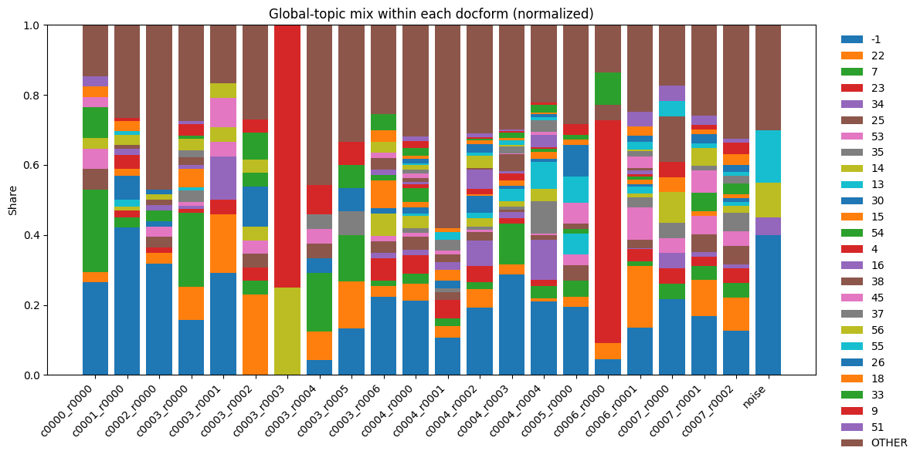
Each bar corresponds to a refined document form cluster and each colored segment represents the proportion of documents within that form assigned to a particular global topic. A “OTHER” category aggregates low frequency topics in each of the bars.
Key observations:
- Several document form clusters are dominated by one or two global topics, indicating strong alignment between structural form and semantic content.
- Other document-form clusters exhibit a heterogeneous topic mix, suggesting that the same structural format can host multiple semantic themes.
- The same global topic appears with different prevalence across document forms, implying that topic frequency estimates are not invariant to document structure.
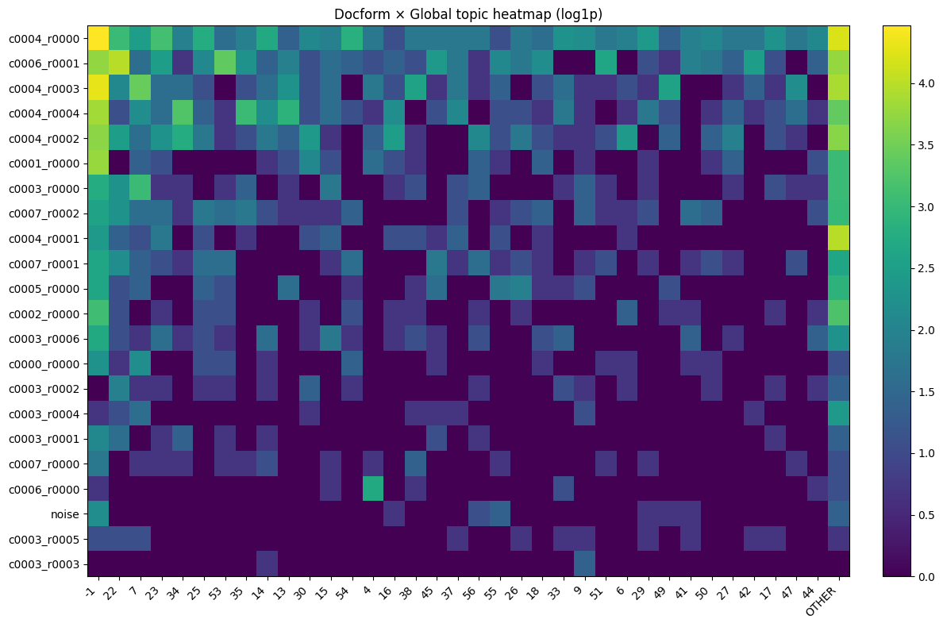
Above heatmap provides a log scaled counts of topic assignments for each intersection of document form clusters and global topic clusters.
Key observations:
- The heatmap reveals block-like structures, where certain document forms strongly concentrate on specific topics.
- Several topics are nearly absent from some document forms while being highly concentrated in others.

Findings
Topic modelling on large, heterogeneous document corpora require explicit separation of structural and semantic variation to yield interpretable topic models. Thorough preprocessing, near-duplicate removal, and document-form clustering, the analysis established a principled unit of semantic observation and reduced the influence of templating and metadata artifacts.
By performing topic modelling both globally and within document-form clusters, the analysis was able to disentangle semantic variation from structural regularities. This approach produced more coherent and interpretable topic clusters, while preserving the ability to compare themes across the corpus.
Overall, the resulting topic structures are suitable for downstream ontology engineering and network-based analyses, where structural bias would otherwise propagate into higher-level representations.

The Named Entities Recognition
In this part of the project, we mostly concentrated on retrieving the named entities (particularly people) from the bunch of documents with different structure. For the sake of simplicity and consistency, we applied pretrained NLP tools (particularly “SpaCy” python library) to prepare the documents for the analysis and extract the entities. Although some authors provide evidence that Large Language Models (LLM’s) are more accurate in terms of entity recognition tasks (Chantrapornchai and Tunsakul, 2021), SpaCy requires less time and computational power compared to LLM’s.

The data preparation
Although tokenization and linguistic annotation are performed automatically, still SpaCy needs relatively clean text as an input. In addition to this, it does not perform well on big unstructured documents. Consequently, the first step of the data preparation was dividing text into blocks, removing artifacts from the text (mostly specific PDF, OCR and html artifacts), and removing repeating standard phrases which do not contain any useful information (standard e-mail disclaimers, for instance). The block division was performed based on manually created rules. We must recognize the part of the document as a new block in case of line breaks (or other symbols dividing blocks) presence. Although some authors insist on token number approach (Amancio, 2016), this technique could not be used in our case because of different sizes of the documents.
However, the tool applied still might struggle to process huge blocks of text. Although in some cases entities can be recognized from relatively big blocks of texts (Amancio, 2016), some scholars state that in order to effectively retain named entities, it is important to utilize sentence-level approach (Wang and Wang). Dividing blocks into sentences could be performed with manually created regex-based rules. Unfortunately, we need to deal with highly unstructured text which might still contain some artefacts, inconsistencies or missed punctuation. That is why it was decided to utilise SpaCy not only for entity recognition but also for sentence division task. The tool is able to recognize not only punctuation and capitalisation but also the surrounding words and grammar which makes it more appropriate for identifying the separate sentences within the blocks.

Entities extraction and graph construction
Finally, when each document was divided into sentences, we proceeded with entity recognition. We mainly focused on recognition of individuals, not all the possible named entities. Fortunately, SpaCy is able to recognize names along with surnames, so we could avoid retaining separate names and surnames representing the same person.
We constructed the graph based on co-occurrence within one document. Each named entity (person) was represented as node, and co-occurrence within the same document was depicted with an edge. However, the number of co-occurrences was dramatic, subsequently, in order to make the graph interpretable, we chosen top 150 entities based on their weighted degree. For each edge, the weight was computed. In fact, it is just the number of documents in which each two entities (nodes) co-occur. The sum of all weights for a specific person is weighted degree. In addition to filtering top 150 nodes, we also filtered out weak connections (in our case,, we depicted only the edges having weights lying in the 4th percentile).
Although the entities were collected through automatized NLP tool, the scope of nodes needed manual adjustment. Based on the filtered graph, we manually deleted entities which do not actually represent person’s name or surname. In addition to this, we needed to map the people appearing under different names based on our knowledge and open-source data (for instance, Bashar Assad and Bashar al-Assad). It was crucial to perform the mapping in responsible way, as we could represent two different people as the same one. We did not map the surnames to the names (for instance, person called Donald was not mapped to Donald Trump).

SOCIAL NETWORK ANALYSIS
For the Social Network Analysis purpose adding more people than 150 nodes added a lot of junk data, as well as severely worsened the computation performance. Therefore, we trimmed the graph to 150 most influential nodes. The following metrics were calculated:

Centrality Measures
Centrality measures help understand which nodes are the most important in the graph. We calculated Degree, Betweenness, Closeness, and PageRank centralities. Figure 1 shows a graph where the size of the node represents PageRank, and the colour of the node represents the Betweenness centrality. It can be visible that there are a few highly influential people that dominate the graph, while the rest do not transit many connections compared to the biggest nodes.
Moreover, Table 1 shows the values of the centrality measures that have been calculated. Betweenness Centrality drops drastically after the first three entries, while other metrics decline steadily. This means that while the graph is quite dense, very few nodes serve as a power bridge in the network.
Rank | Name | Degree Centrality | Betweenness Centrality | Closeness Centrality | PageRank
1 | Jeffrey Epstein | 0.745 | 0.742 | 11.599 | 0.052
2 | Barack Obama | 0.933 | 0.485 | 11.432 | 0.031
3 | Donald Trump | 0.779 | 0.179 | 11.420 | 0.033
4 | Clinton | 0.872 | 0.130 | 11.282 | 0.033
5 | Bill Clinton | 0.866 | 0.106 | 11.197 | 0.034
6 | Bush | 0.832 | 0.032 | 9.905 | 0.019
7 | Michael | 0.624 | 0.026 | 9.809 | 0.013
8 | David | 0.792 | 0.022 | 9.731 | 0.015
9 | John | 0.812 | 0.021 | 8.676 | 0.015
10 | Robert | 0.228 | 0.009 | 8.417 | 0.004
Table 1: Centrality measures.

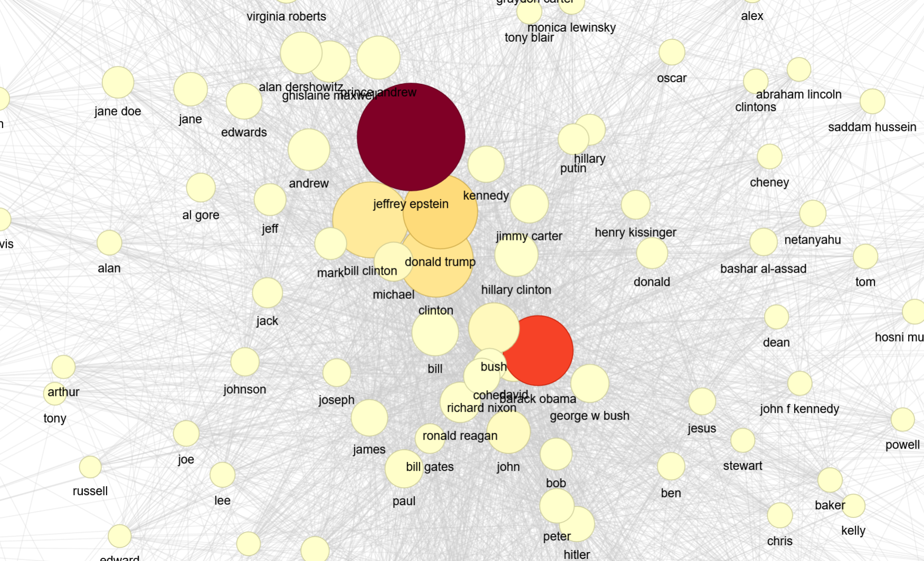 Figure 1: Betweenness and Pagerank graph.

Communities
Next, we analyse the communities. There turned out to be 3 communities total with the following breakdown:
Community 1: 107 members
Community 2: 37 members
Community 3: 6 members
The graph representing the communities is shown in Figure 2. It seems that the Community 3 is the “outliers” community, while the other 2 are populated with tightly connected nodes that frequently interact with each other.
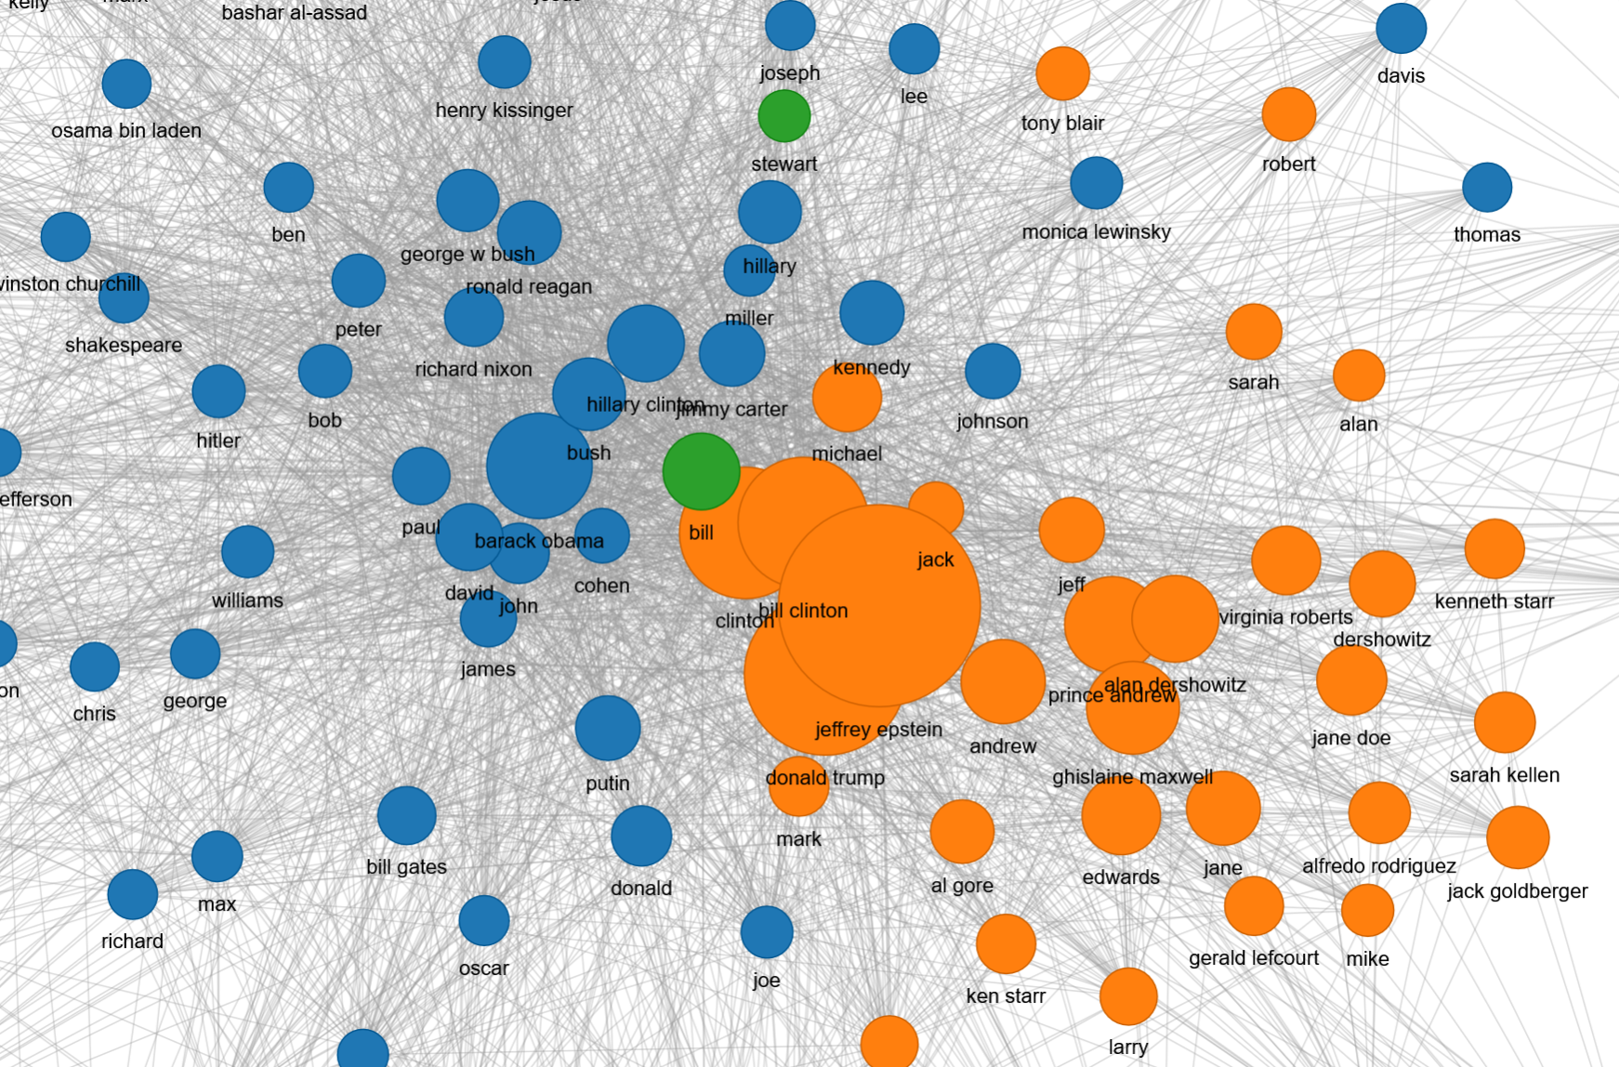 Figure 2: Communities. Communities 1, 2, 3 are represented by blue, orange, and green colours respectively.

Assortativity
Assortativity analysis aims to describe how similar the connections are with respect to the node degree. In other words, are popular nodes tend to be connected to other popular nodes, or less popular ones. The Degree Assortativity score for the analysed network is –0.12, meaning the graph is very disassortative, i.e. high-degree vertices tend to link with low-degree nodes. Table 2 shows the Top 10 nodes by average neighbour degree.
Rank | Name | Avg. Neighbor Degree | Own Degree
1 | Bloomberg | 108.54 | 9
2 | Tim | 105.06 | 11
3 | Jim | 99.54 | 23
4 | Robinson | 98.44 | 12
5 | Russell | 96.17 | 21
6 | Kaplan | 95.79 | 10
7 | George W | 93.97 | 17
8 | Brexit | 92.73 | 16
9 | Don | 91.39 | 25
10 | Robert | 90.82 | 34
Table 2: Assortativity of the graph.

Clustering
Clustering measures show how tightly woven the network is. We calculated plain clustering, triangles, and transitivity of the graph. Moreover, we calculate the Maximum Spanning tree as shown in Figure 3. The top nodes by triangle participation, as well as their clustering coefficients, are presented in the Table 3. The Maximum Spanning tree is shown in Figure X. The MST shows that there are 2 nodes that have strong connections to the majority of the network, namely Jeffrey Epstein and Barrack Obama. Surprisingly, the table shows a slightly different picture: Jeffrey Epstein is on the 9th spot when it comes to triangle count.

Rank | Name | Clustering Coefficient | Triangle Count
1 | Barack Obama | 0.336 | 3,219
2 | Clinton | 0.364 | 3,048
3 | Bill Clinton | 0.364 | 3,007
4 | Bush | 0.380 | 2,897
5 | Bill | 0.386 | 2,707
6 | John | 0.372 | 2,703
7 | David | 0.381 | 2,631
8 | Donald Trump | 0.387 | 2,583
9 | Jeffrey Epstein | 0.398 | 2,427
10 | Ronald Reagan | 0.449 | 2,314
Table 3: Top nodes by Triangle count, as well as clustering coefficients
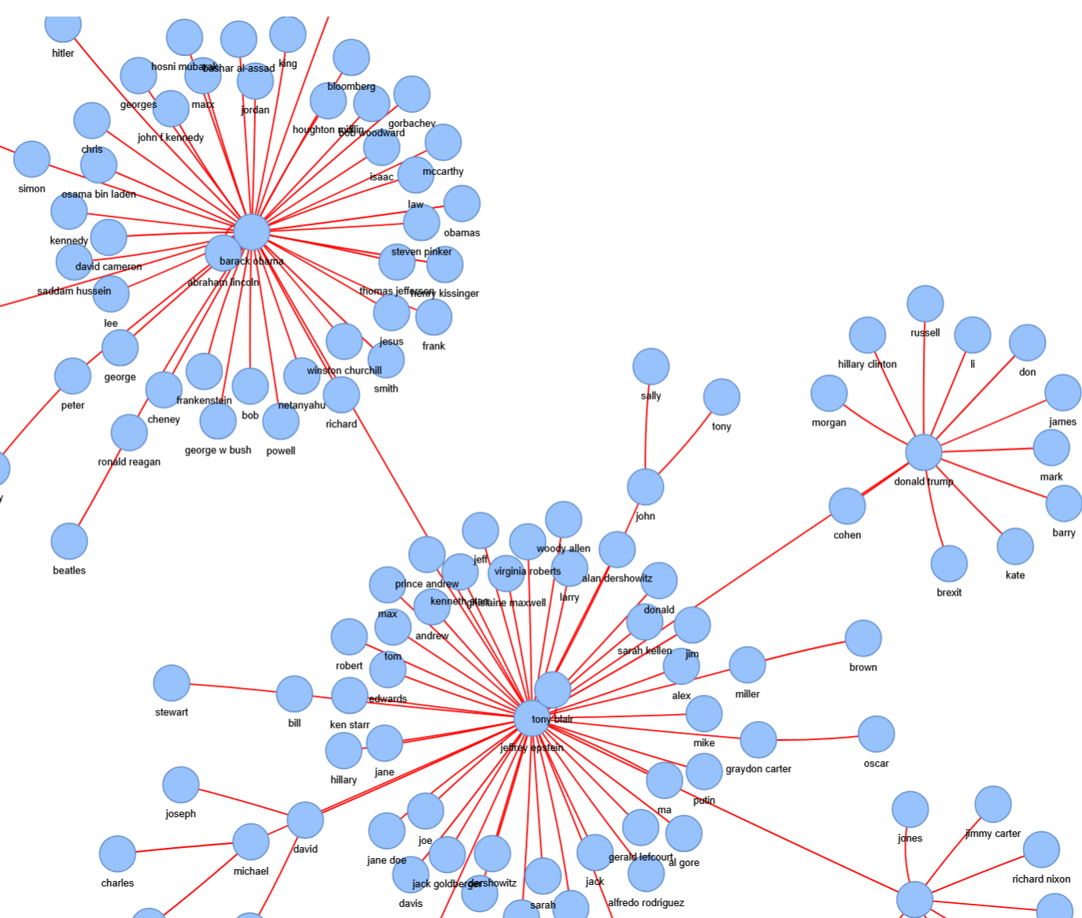 Figure 3: Maximum spanning tree.

SNA Conclusions
Looking at this analysis we can come to certain conclusions. The network shows high degree of centrality: The top nodes in the centrality analysis are obvious critical “hubs”. The MST also supports this conclusion, with 2 nodes being directly connected to the majority of the graph. Moreover, the network shows high clustering properties: the top nodes participate in 2000+ triangles, given that the network only contains 150 nodes. Finally, the assortativity analysis further supports the conclusion; since it is disassortative, there are many nodes that have average neighbour degree much higher than own degree, again pointing to the presence of critical hubs in the network.

Bibliography
1. Chantrapornchai, C., Tunsakul, A., (2021), “Information Extraction on Tourism Domain using SpaCy and BERT”, ECTI TRANSACTIONS ON COMPUTER AND INFORMATION TECHNOLOGY, Vol.15 (1).
2. Amancio, D., (2016), “Network analysis of named entity co-occurrences in written texts”.
3. Wang, X., Wang Y., “Sentence-Level Resampling for Named Entity Recognition” Proceedings of the 2022 Conference of the North American Chapter of the Association for Computational Linguistics: Human Language Technologies, pp 2151- 2165.
4. Dekker N, Kuhn T, van Erp, M., (2019), “Evaluating named entity recognition tools for extracting social networks from novels”, PeerJ Computer Science.
5. Saravanan, K., Choudhury, M., Udupa, R., Kumaran, A., (2006), “An Empirical Study of the Occurrence and Co-Occurrence of Named Entities in Natural Language Corpora”, Published as a part of the Cross-Language Evaluation Form (CLEF) corpora in 2006 & 2007.
6. Bazzo G., Lorentz, G., Vargas, D., Moreira, V., (2020), “Assessing the Impact of OCR Errors in Information Retrieval”
7. Sood, S., Loguinov, D., & Saha, B. (2011), “Probabilistic Near-Duplicate Detection Using Simhash”
8. Kan, M.‑Y., & Thi, H. O. N. (2005). “Fast webpage classification using URL features.”
9. McInnes, L., Healy, J., & Melville, J. (2018). “UMAP: Uniform Manifold Approximation and Projection for Dimension Reduction”
10. Campello, R. J. G. B., Moulavi, D., & Sander, J. (2013). “Density‑Based Clustering Based on Hierarchical Density Estimates.”
11. Grootendorst, M. (2022). “BERTopic: Neural Topic Modeling with a Class‑based TF‑IDF”

